Name | SHAIK FARHAAN FATIR
Class | 7 A1

Purpose:
"Skill Assessment Program - Building Strengths Beyond Academics "
This report shows your child's interests and abilities in different school activities. With your (parents) support and our guidance, these strengths can grow into useful life skills. It helps parents notice early signs of talent and areas where extra care or practice can make a big difference.

Key Insights:
The graph below shows how your child is doing in different areas. It tells us what they like more and where we can help them do even better. Blue represents your child, and red represents the class average.
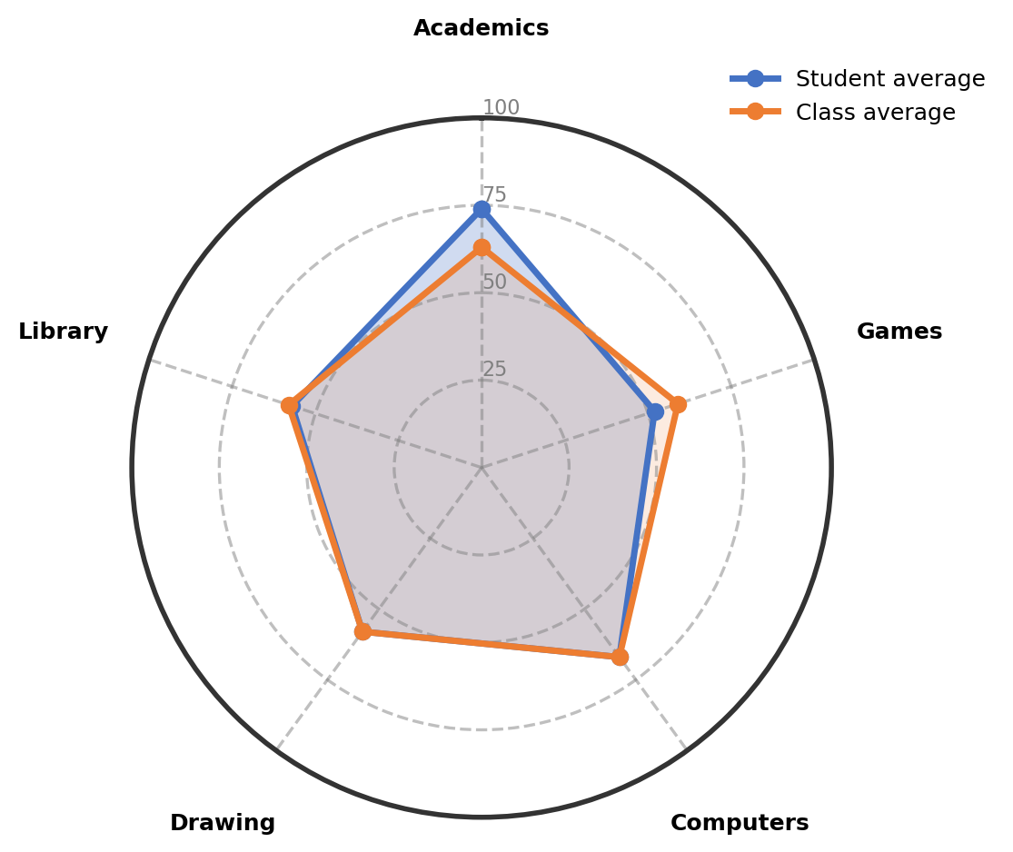

Observations:
The table gives an overview of child's involvement and performance across co-curricular areas.
Interest Area | Engagement (%) | Interest Level | Key Observations
Academics | 74% | Well-Developed Interest | Shows strong understanding in mathematics, social studies, and science subjects. The consistent performance reflects good learning habits.
Computers | 67% | Growing Strength in This Area | Shows interest in basic computer skills like drawing and typing. With regular practice and motivation, performance continues to improve.
Drawing | 58% | Progressing With Guidance | Creates neat and accurate drawings with good finishing. Shows particular interest in anime-style artwork and creative expression.
Library | 57% | Emerging Interest | Enjoys reading story books and shows good comprehension. The growing interest in reading is a positive development.
Games | 52% | Building Confidence Gradually | Enjoys playing shuttle and short cricket with growing interest. Participation is becoming more focused and engaged.

Recommendations & Growth Opportunities:
Here are some ways to turn your child's interests into long-term strengths:
Strong Interest Area | Potential Careers | Simple Activities to Support
Computers  (67%) | This growing strength in computers can lead to exciting career fields in technology. Exploring software development, graphic design, data analysis, or digital content creation becomes possible. Building strong technical skills now creates a solid foundation for many future opportunities. | Enroll in a structured computer basics course at a local coaching center to strengthen typing speed and basic software skills
Drawing  (58%) | This progressing interest in drawing can connect to creative career fields in design and visual arts. Considering animation, illustration, graphic design, or architecture becomes relevant. Developing attention to detail and creative expression benefits many artistic and technical fields. | Join a structured drawing class focusing on anime and figure drawing techniques to improve accuracy and style development

How Parents Can Help:
1. Weekend Exploration (Computers): Dedicate a Saturday morning to a guided online tutorial that teaches basic graphic design or simple animation, connecting it to the interest in drawing and computers.
2. Short Daily Practice (Drawing): Encourage 15 minutes of practicing anime character sketches or geometric shapes in the evening to maintain the interest in exact measurements and creative expression.
3. Encourage and Talk: Dedicate 10-15 minutes weekly to discuss favorite story books or anime characters and offer appreciation for the effort in reading and drawing activities.

Conclusion:
The child shows wonderful natural strengths in both technical and creative areas. The growing interest in computers and drawing, combined with strong academic performance, creates a balanced foundation for future exploration. At this stage, maintaining curiosity and building skills through structured learning is most important. Every child develops at their own pace, and this steady progress in multiple areas is truly encouraging. Focus on providing supportive opportunities while celebrating the natural interests that continue to emerge.

Notes:
Parents remarks:
Teachers' remarks:

